Assignment 7: Test Cases Documentation
Student Name: Tara Rai
Date: February 7, 2026

Initial city_functions.py Execution (City + Country Only)
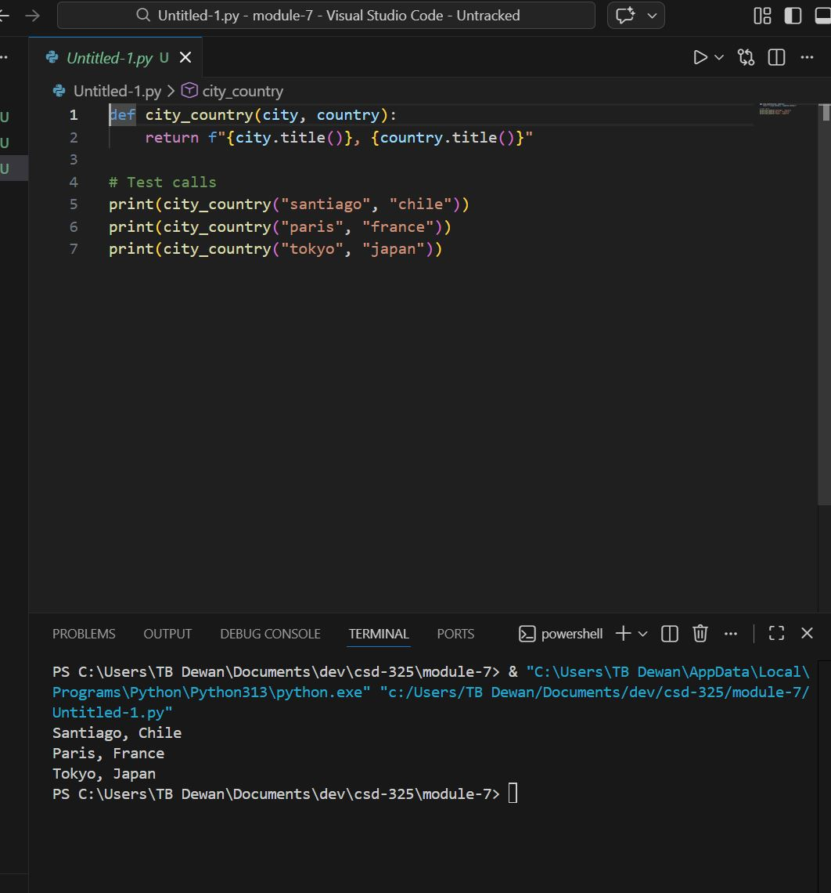

Initial Test Pass (Basic Test)
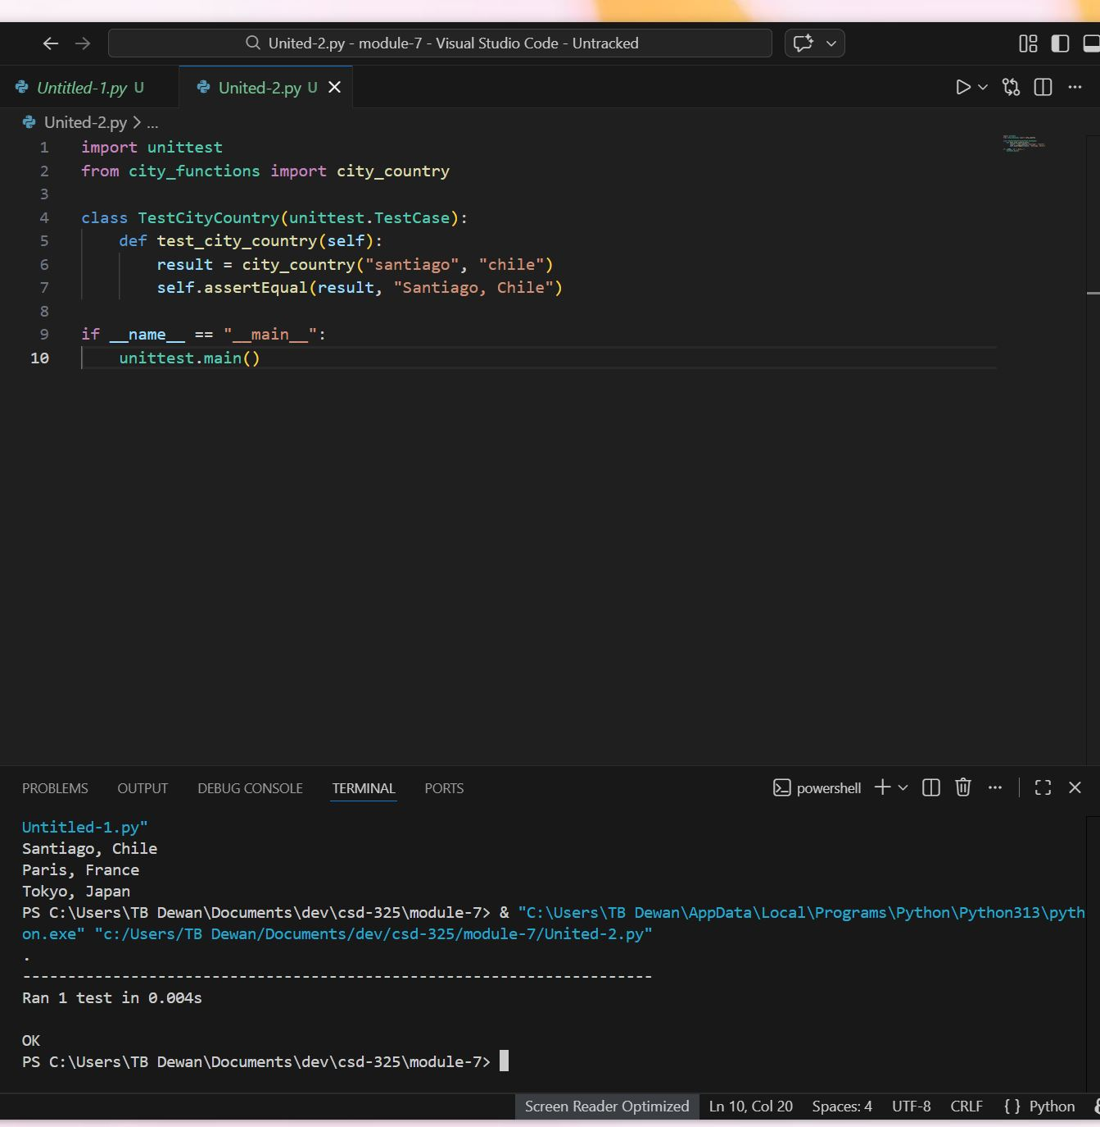

Test Failure After Adding Required Population Parameter

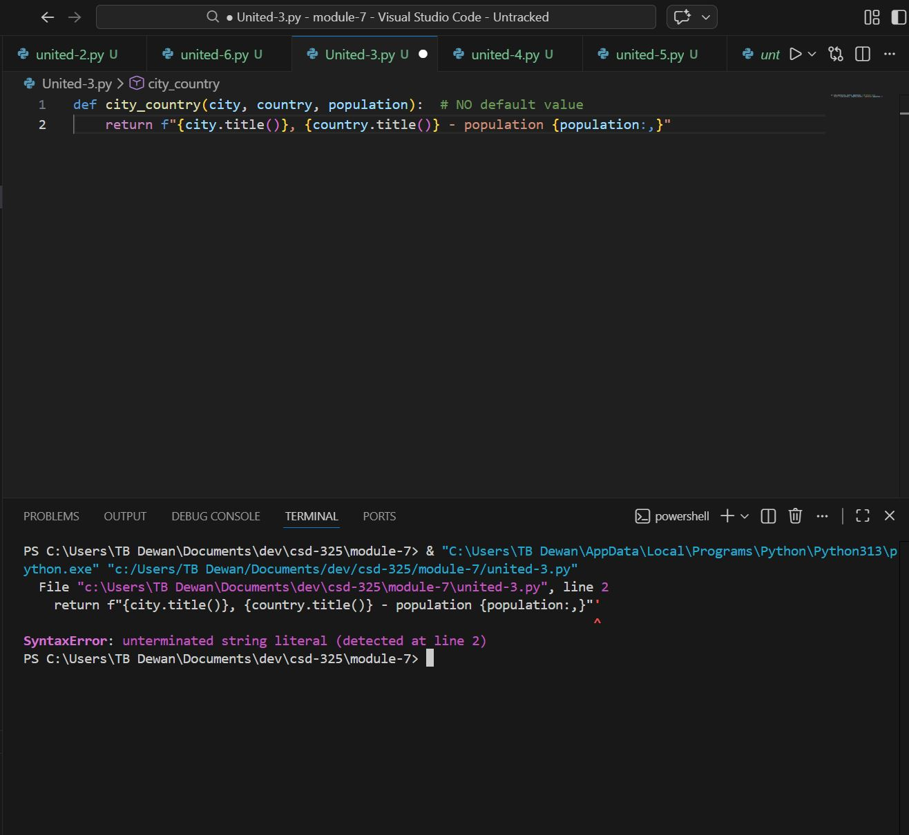

Test Pass After Making Population Optional
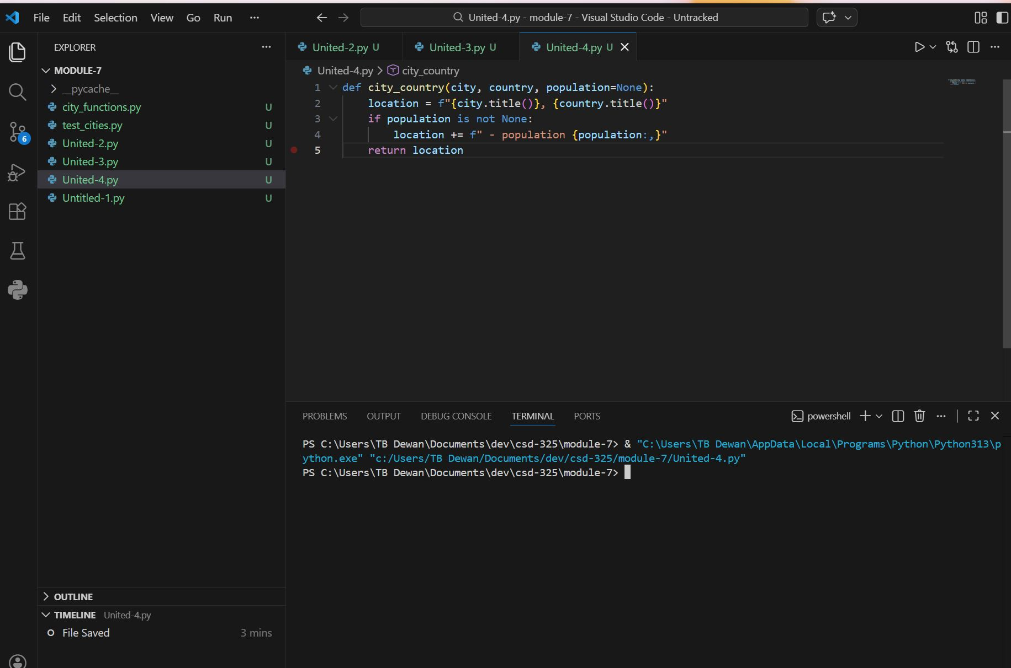

Final city_functions.py Execution (All Parameter Combinations)
